**A Summer Project Report of the Visualization on Radar-based Vital Signs**

# Introduction

This is a full-time summer research project, that aims to complement the existing research on a Radar-based method for remote monitoring vital signs, and the initial results are promising regarding the accuracy of heart rate and respiratory rate measurements in an indoor office environment.

My research work is to take end-to-end visualization of vital signs, encompassing user interface prototyping, design, and development when integration with Radar components. My overall contributions are summarized as follows:

* Prototype and design a Web/Mobile-based user interface (UI) to visualize vital signs(Heart Rate, Respiration Rate) based on the current best practices in human-computer interaction (HCI).
* Develop a Web/Mobile-based Application to visualize and monitor vital signs(Heart Rate, Respiration Rate).
* Integrate with the data of vital signs (HR and RR) computed by the extent radar system.

# System Physical Overview

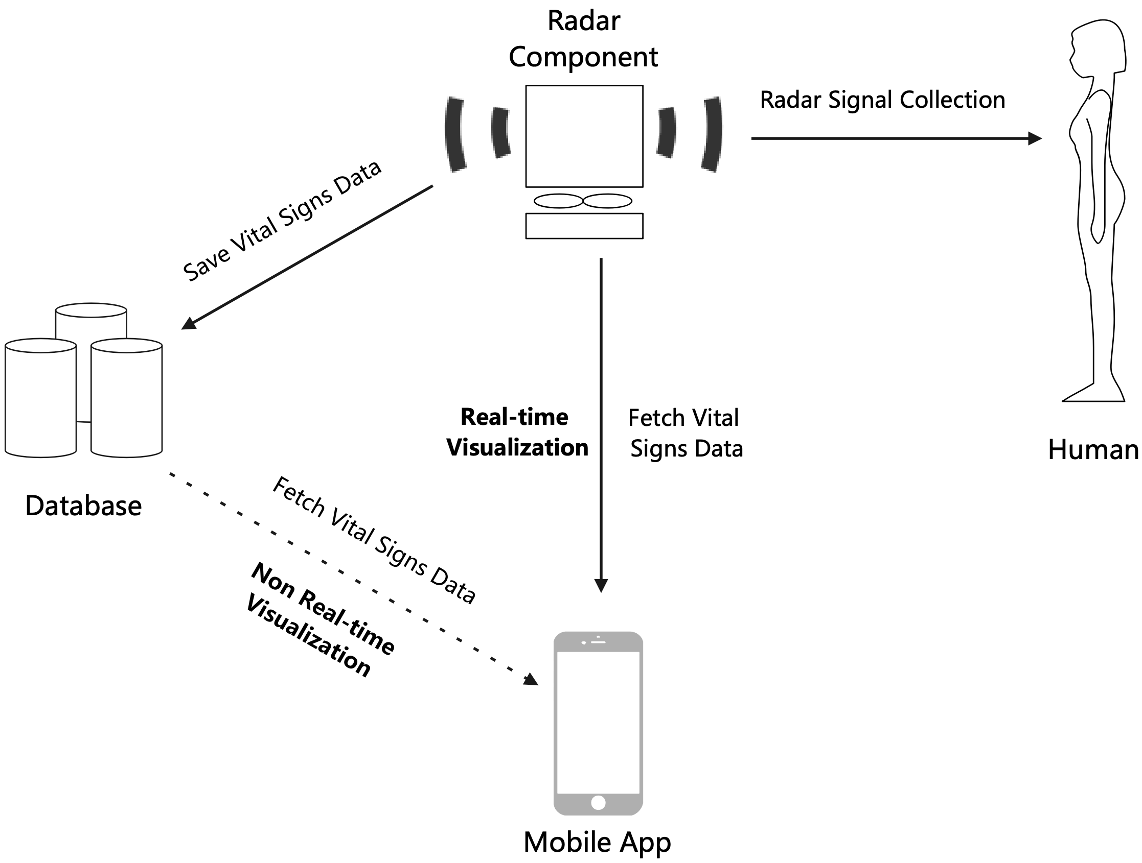

Figure 1: The System Physical Overview

Physically, as depicted in Figure 1, the system mainly comprises a radar component, a database, and a mobile application. The radar component aims to collect radar signals from humans and extract vital signs from the radar waves using a designed signal processing-based algorithm. The database stores two distinct types of data: the raw radar signals collected from participants and the vital signs derived by the designed algorithm.

The mobile application, which is the main scope of the summer research project, aims to visualize these vital signs either in real-time or non-real-time. Real-time visualization occurs when the mobile application receives vital sign data directly from the radar component. Non-real-time visualization happens when the application retrieves the stored vital signs from the database.

# Technical Stack and Constraints

As estimating vital signs from radar signals using deep learning models is one of the research focuses, Python is chosen as the backend programming language to facilitate easier integration with deep learning models in the future and enhance software development efficiency. The specific technology stack and constraints are as follows:

* Back-end

Primary language: Python

Framework used: Django

Description: Django is a high-level web framework for the Python programming language that enables the rapid development of secure and maintainable websites. In this project, we utilize Django as the backend server to process the data and return the data of vital signs to the client.

* Front-end

Primary language: Javascript, HTML5, CSS

Framework used: jQuery, Echart, TailwindCSS

Description: The TailwindCSS framework is utilized to control the layout, such as colors, fonts, and overall appearance of the visualization page. The framework jQuery and Echart are utilized for the data request and response processing between the front-end and back-end, as well as the waveform presentation of heart and respiratory rates.

* Data Storage Format

CSV File

Description: CSV files are used to save the data of the vital signs of each participant.

# User Interface Prototype

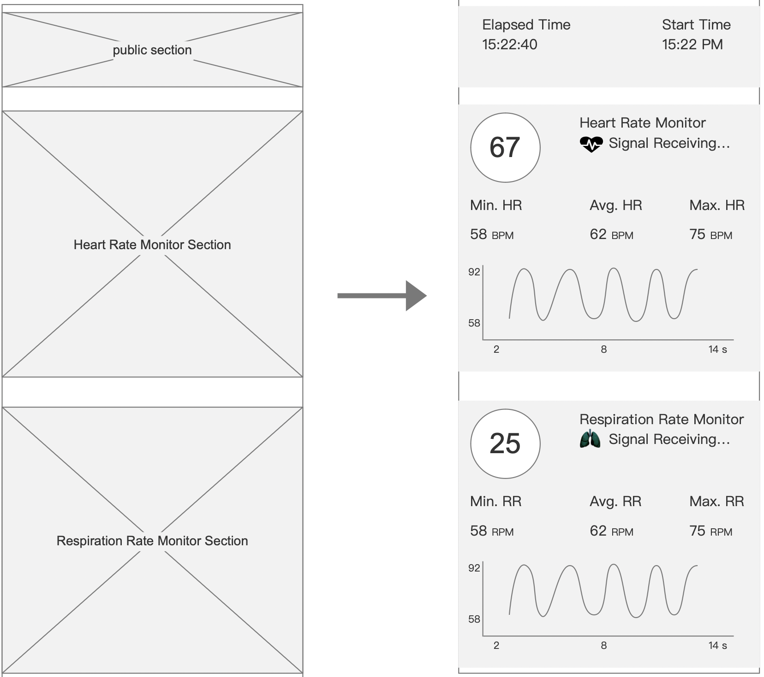

# User Interface Design

# Project Presentation